Firebrand flux

186 m

0 m

320 m

FBP X

FBP Y

FBP Z

FCS X

FCS Y

FCS Z

Fire line

Road

320 m

160 m

300 m

250 m

150 m

100 m

50 m

Forest fire simulations

Wind field development

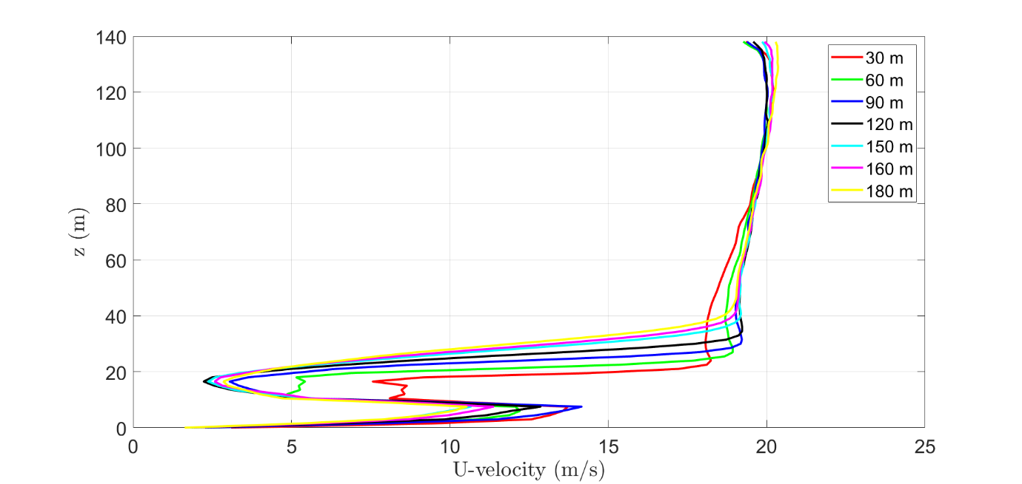

Note: Fire has been started(at 120 s). Particle inputting has been started(at 130 s). Current simulation time is 141 s.

Collection time span (s)

FCS X – 407 s

FCS Y – 513 s

FCS Z – 394 s

|  |  |  |  |  |  |  |  |  |  |
| --- | --- | --- | --- | --- | --- | --- | --- | --- | --- |
| **Case** | **Wind velocity**  **(m/s)** | **Particle velocity**  **(U,V,W) m/s** | **Input rate pcs/s** | **Flux (pcs/m2. s)** | | | **Number of Firebrands(pcs)** | | |
| **FCS Z** | **FCS Y** | **FCS X** | **FCS Z** | **FCS Y** | **FCS X** |
| TH valid- grid(0.75 m) | ≈2.2 | (8.3, 0.0, 2.1) | 11006 | 1.946 | 0.977 | 0.798 | 767 | 497 | 325 |
| TJ valid- grid(0.75 m) | ≈2.17 | (8.3, 0.0, 2.1) | 12367 | 1.625 | 1.170 | 0.641 | 640 | 600 | 261 |
| Experiment | 1.4±0.6 | NA | NA | 1.361 | 0.902 | 0.824 | 536 | 463 | 335 |
| Difference(%)  (Exp /TH valid) |  |  |  | 30.1% | 07.6% | -03.3% | 30.1% | 07.6% | -03.3% |
| Difference(%)  (Exp /TJ valid) |  |  |  | 16.2% | 22.9% | -28.5% | 16.2% | 22.9% | -28.5% |

|  |  |  |
| --- | --- | --- |
| **Case** | **Total amount of firebrands at Z+Y+X (pcs)** | **Difference with the exp.**  **(%)** |
| Experiment | 536+463+335= 1334 |
| TH valid- grid(0.75 m) | 767+497+325=1589 | 16 |
| TJ valid- grid(0.75 m) | 640+600+261=1501 | 11 |

Comparison of firebrand flux at X, Y and, Z location in the experiment and the simulation.

|  |  |  |  |  |  |  |  |  |  |
| --- | --- | --- | --- | --- | --- | --- | --- | --- | --- |
| **Area**  **(x 10-5)[m2]** | **Firebrand number at collection sites (pcs)** | | | | | | | | |
| **Experiment** | | | TH valid- grid(0.75m) | | | TJ valid- grid(0.75 m) | | |
| **FCS X** | **FCS Y** | **FCS Z** | **FCS X** | **FCS Y** | **FCS Z** | **FCS X** | **FCS Y** | **FCS Z** |
| **0.75 - 5** | 264 | 352 | 413 | 266 | 470 | 453 | 214 | 535 | 109 |
| **5 - 10** | 42 | 69 | 74 | 1 | 21 | 115 | 1 | 2 | 5 |
| **10 -20** | 22 | 32 | 34 | 0 | 5 | 12 | 1 | 44 | 178 |
| **20 -30** | 2 | 4 | 9 | 0 | 2 | 56 | 0 | 12 | 307 |
| **30 - 50** | 3 | 2 | 5 | 0 | 1 | 78 | 0 | 5 | 27 |
| **>50** | 2 | 4 | 2 | 0 | 1 | 54 | 0 | 2 | 14 |

**Firebrand flux: Experiments vs simulation at X, Y, Z locations**

|  |
| --- |
|  |
|  |
|  |

Average heat release rate (MW) = 2391 (from 122 s to 170 s)

Firebrands inputting rate = 12367 pcs/s

Firebrands inputting rate vs fire intensity = $\frac{12367\frac{pcs}{s}}{2391 MW}$

$=5.17\frac{pcs}{MW. s}$